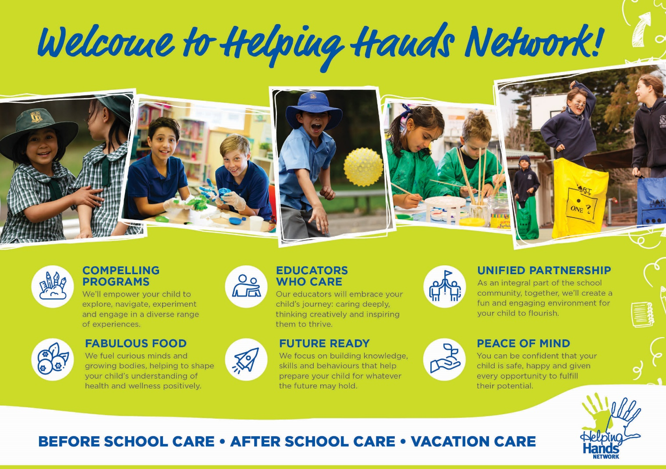
Welcome to Helping Hands Woongoolba!
At Helping Hands Network, we pride ourselves on providing children with fun, play-based learning experiences that meet all your family’s needs. You can be confident that your child is in safe hands with our experienced and passionate educators. Whether your child attends Helping Hands Network daily or only occasionally, each visit is an exciting new adventure with healthy, nutritious food, awesome clubs, activities and so much more.
How to enrol
Enrolling with Helping Hands is easy and completely free. We don’t charge any annual registration fees.
Click here to create an account and complete our online enrolment form. Select the Helping Hands service for your child’s school and enter all required information into the relevant fields. Once enrolled, you can manage your bookings and cancellations with ease online.
Your child’s enrolment must be confirmed before attending their first session with us. If at any time your family details or emergency contacts change, please update them through our website so that our records remain current.
Child Care Subsidy (CCS)
Many families are eligible for Child Care Subsidy, which can reduce the cost of Outside School Hours Care by up to 85%. All our services are CCS approved, so we encourage all families to find out whether they are eligible. To establish what level of CCS you may be entitled to please contact the Centrelink Family Line on 13 61 50.
Join the fun at Helping Hands
For more information speak to our friendly service coordinator on 0419 410 694 or visit our website here.
We look forward to meeting you and your family.

